Bug title: POST endpoint returns 200 instead of 201
Tester’s Name & ID: Antonio Acosta Flores (antonio.acostafl@gmail.com)
Test Environment: https://wmxrwq14uc.execute-api.us-east-1.amazonaws.com
Priority: 5
Severity: 5

Steps to reproduce the bug:

No. Step | Step Description | Expected Result
1 | There is an existent employee with id = “f44933cf-c853-4e38-8dec-108439b59ce5  ” | There is an existent employee with id = “f44933cf-c853-4e38-8dec-10
2 | When calling API to update existent user | The employee is updated and proper code is shown.

Steps with evidence:

No. Step | Step Description | Expected Result
1 | There is an existent employee with id = “f44933cf-c853-4e38-8dec-108439b59ce5  ” | There is an existent employee with id = “f44933cf-c853-4e38-8dec-10

Result:
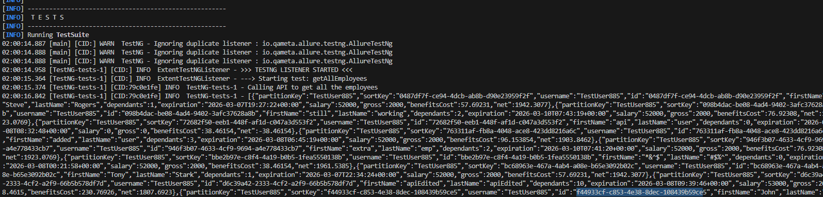

2 | When calling API to update existent user | The employee is updated and proper code is shown.  Actual Result: POST endpoint return 200 instead 201

Result:
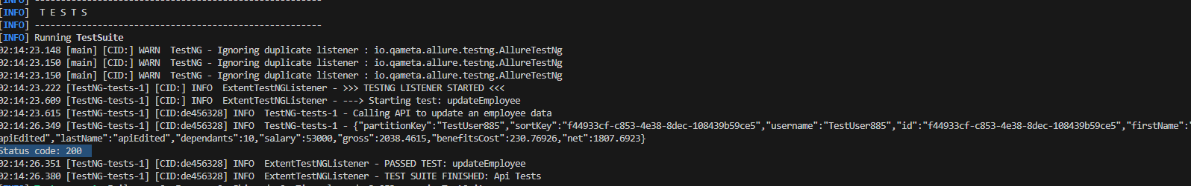

Bug title: Employee is getting created when calling API with an extra invalid field unknownField: shouldFail.
Tester’s Name & ID: Antonio Acosta Flores (antonio.acostafl@gmail.com)
Test Environment: https://wmxrwq14uc.execute-api.us-east-1.amazonaws.com
Priority: 3
Severity: 3

Steps to reproduce the bug:

No. Step | Step Description | Expected Result
1 | There are required fields to send in the payload of the api and no additional Properties are allowed | There are required fields to send in the payload of the api and no additional Properties are allowed
2 | When calling API with additional field | API should not insert a new employee

Steps with evidence:

No. Step | Step Description | Expected Result
1 | There are required fields to send in the payload of the api and no additional Properties are allowed | There are required fields to send in the payload of the api and no additional Properties are allowed

Result:
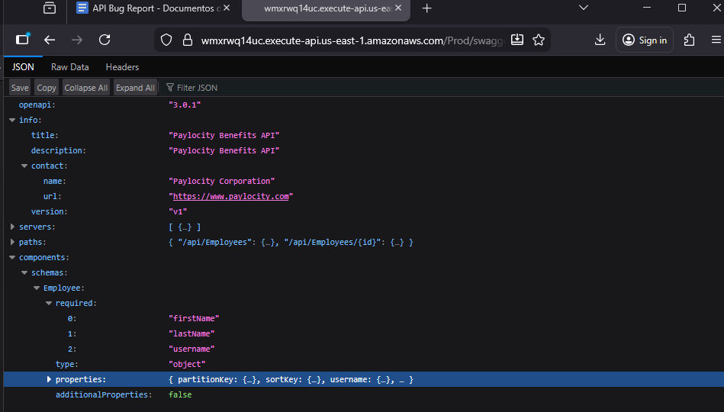

2 | When calling API with additional field | API should not insert a new employee  Actual Result: New employee is inserted.

Result: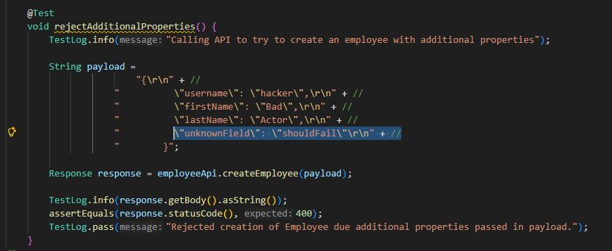

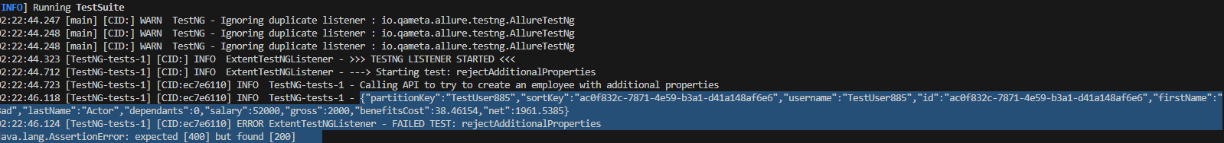

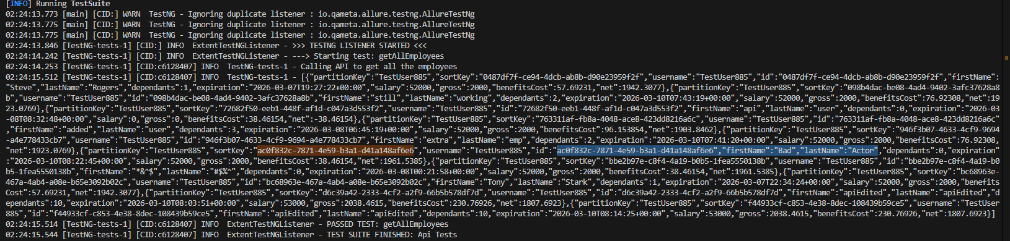

Bug title: Employee is not getting creating when sending and object
Tester’s Name & ID: Antonio Acosta Flores (antonio.acostafl@gmail.com)
Test Environment: https://wmxrwq14uc.execute-api.us-east-1.amazonaws.com
Priority: 3
Severity: 3

Steps to reproduce the bug:

No. Step | Step Description | Expected Result
1 | There are the specification in the swagger that an object can be accepted to create a new employee | There are the specification in the swagger that an object can be accepted to create a new employee
2 | When calling API with additional field | API should insert a new employee

Steps with evidence:

No. Step | Step Description | Expected Result
1 | There are the specification in the swagger that an object can be accepted to create a new employee | There are the specification in the swagger that an object can be accepted to create a new employee

Result:

2 | When calling API with additional field | API should insert a new employee  Actual Result: New employee is not inserted.

Result:
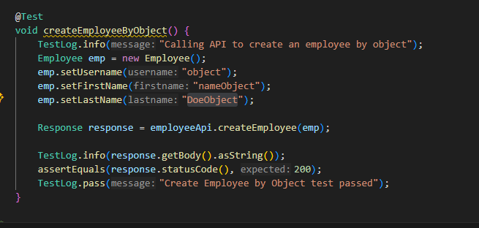

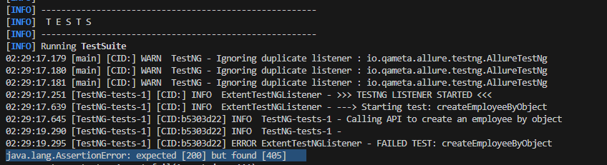

Bug title: New employee does not take the salary specified in the payload (80000) and put the default salary (52000)
Tester’s Name & ID: Antonio Acosta Flores (antonio.acostafl@gmail.com)
Test Environment: https://wmxrwq14uc.execute-api.us-east-1.amazonaws.com
Priority: 3
Severity: 3

Steps to reproduce the bug:

No. Step | Step Description | Expected Result
1 | There are not a firstname: John  and lastname: Doe employee created in the dashboard | There are not a firstname: John  and lastname: Doe employee created in the dashboard
2 | When calling API with additional field | API should insert a new employee

Steps with evidence:

No. Step | Step Description | Expected Result
1 | There are not a firstname: John  and lastname: Doe employee created in the dashboard | There are not a firstname: John  and lastname: Doe employee created in the dashboard

Result:
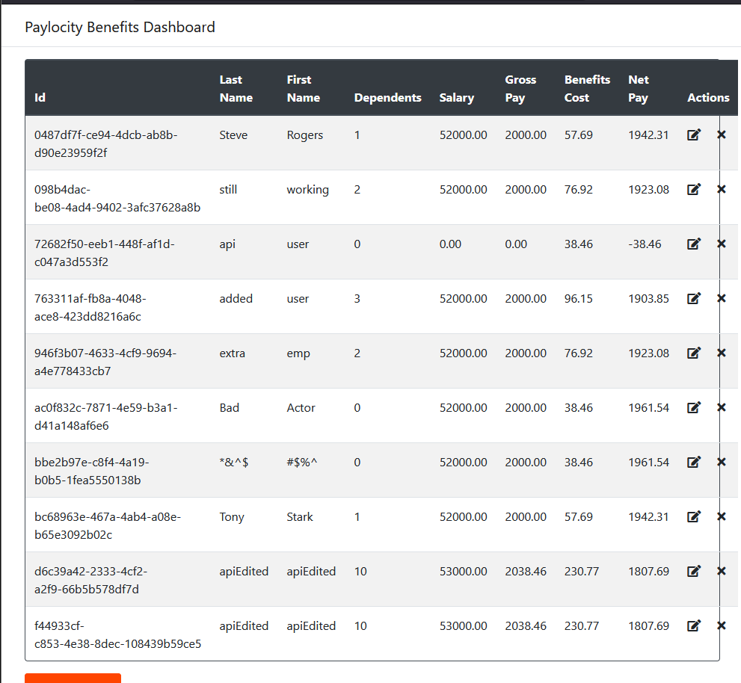

2 | When calling API with the salary specified | API should insert a new employee with the salary specified  Actual Result: Employee is created with the default salary not with the parameter valid specified in the swagger “salary”

Result:
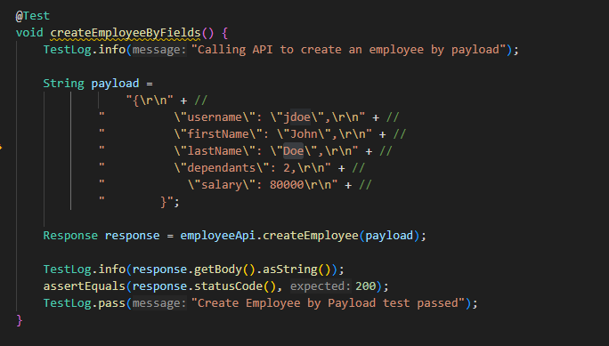

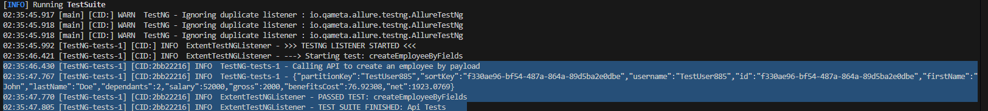

Bug title: No traceability in UI for the user when adding a record with the expiration date specified in the payload
Tester’s Name & ID: Antonio Acosta Flores (antonio.acostafl@gmail.com)
Test Environment: https://wmxrwq14uc.execute-api.us-east-1.amazonaws.com
Priority: 3
Severity: 3

Steps to reproduce the bug:

No. Step | Step Description | Expected Result
1 | expiration date can be specified in the swagger | expiration date can be specified in the swagger
2 | There is no traceability for the user to see the expiration date when getting all the employees compared with the UI | There is no traceability for the user to see the expiration date in the UI

Steps with evidence:

No. Step | Step Description | Expected Result
1 | expiration date can be specified in the swagger | expiration date can be specified in the swagger

Result:
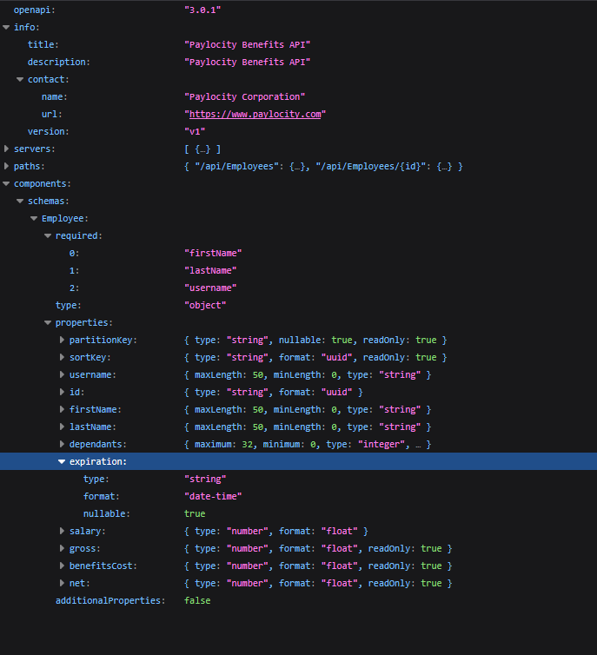

2 | There is no traceability for the user to see the expiration date when getting all the employees compared with the UI | Actual Result: There is no traceability for the user to see the expiration date in the UI

Result:
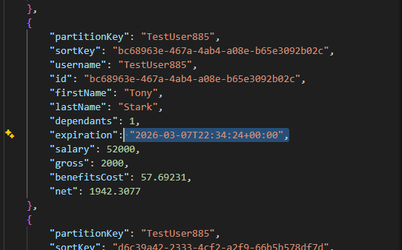

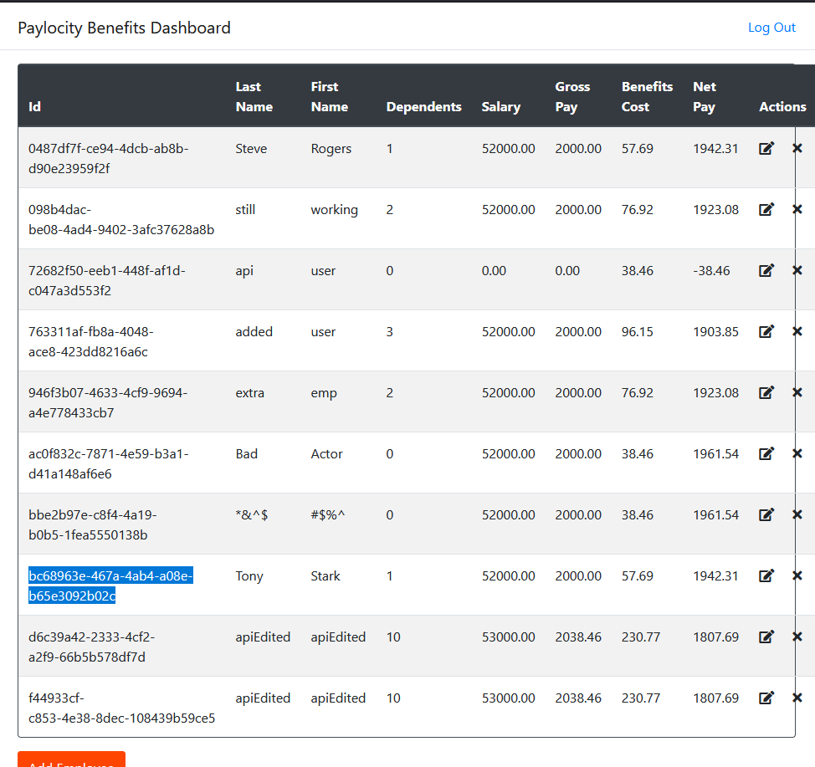

Bug title: Employee can be added with a date less than current date
Tester’s Name & ID: Antonio Acosta Flores (antonio.acostafl@gmail.com)
Test Environment: https://wmxrwq14uc.execute-api.us-east-1.amazonaws.com
Priority: 3
Severity: 3

Steps to reproduce the bug:

No. Step | Step Description | Expected Result
1 | When specifying the expiration date with a date less than the current date in the POST endpoint | When specifying the expiration date with a date less than the current date in the POST endpoint
2 | When executing the API call | Employee should not be created

Steps with evidence:

No. Step | Step Description | Expected Result
1 | When specifying the expiration date with a date less than the current date in the POST endpoint | When specifying the expiration date with a date less than the current date in the POST endpoint

Result:
ecuting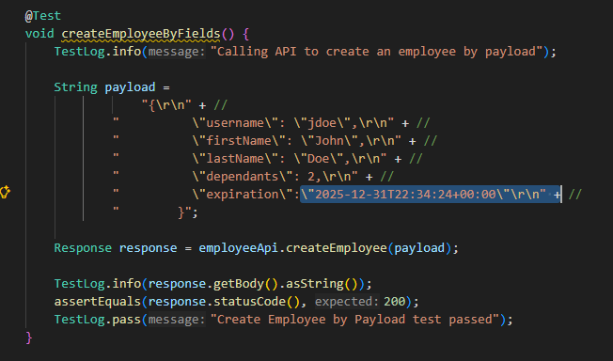

2 | When ex the API call | Employee should not be created  Actual Result: Employee is getting created.

Result:
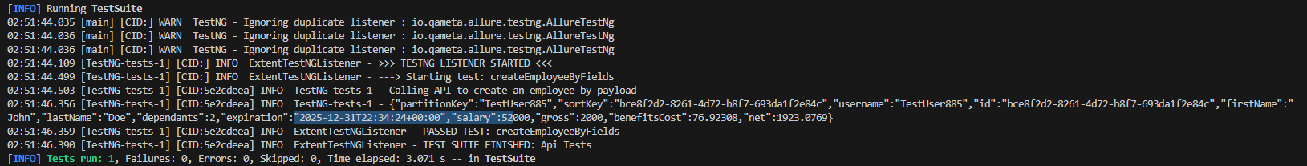

Bug title: When getting all the employees the username shown within the response is not the one specified when creating the employee
Tester’s Name & ID: Antonio Acosta Flores (antonio.acostafl@gmail.com)
Test Environment: https://wmxrwq14uc.execute-api.us-east-1.amazonaws.com
Priority: 3
Severity: 3

Steps to reproduce the bug:

No. Step | Step Description | Expected Result
1 | When specifying the username in the POST endpoint | When specifying the username in the POST endpoint
2 | When executing the API call | Employee should be created with the specified username

Steps with evidence:

No. Step | Step Description | Expected Result
1 | When specifying the username in the POST endpoint | When specifying the username in the POST endpoint

Result:
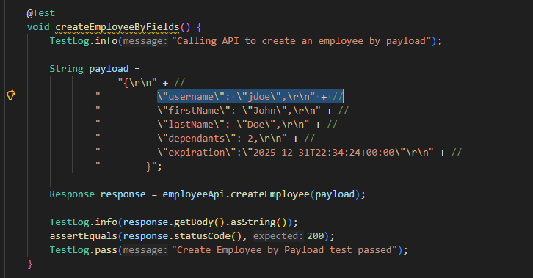

2 | When executing the API call | Employee should be created with the specified username  Actual Result: Employee is getting created.

Result:

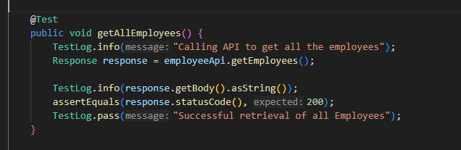

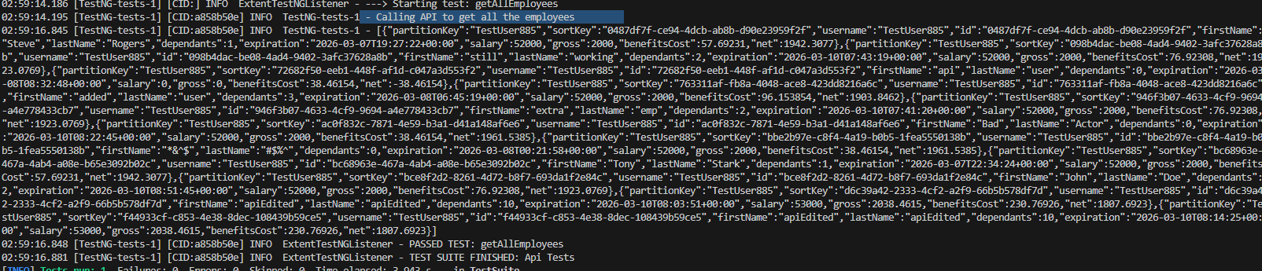

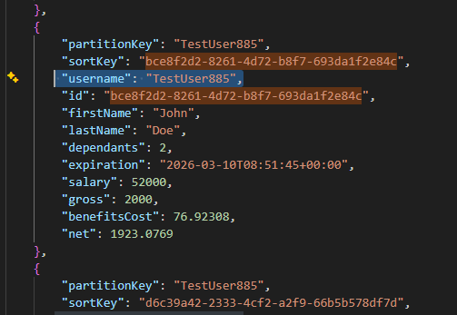

Bug title: Username is not changed after sending the PUT call along with the schema
Tester’s Name & ID: Antonio Acosta Flores (antonio.acostafl@gmail.com)
Test Environment: https://wmxrwq14uc.execute-api.us-east-1.amazonaws.com
Priority: 3
Severity: 3

Steps to reproduce the bug:

No. Step | Step Description | Expected Result
1 | When specifying the username in the POST endpoint of an existent employee | When specifying the username in the POST endpoint of an existent employee
2 | When executing the API call to update the username | Employee should be updated with the specified username

Steps with evidence:

No. Step | Step Description | Expected Result
1 | When specifying the username in the POST endpoint of an existent employee | When specifying the username in the POST endpoint of an existent employee

Result:
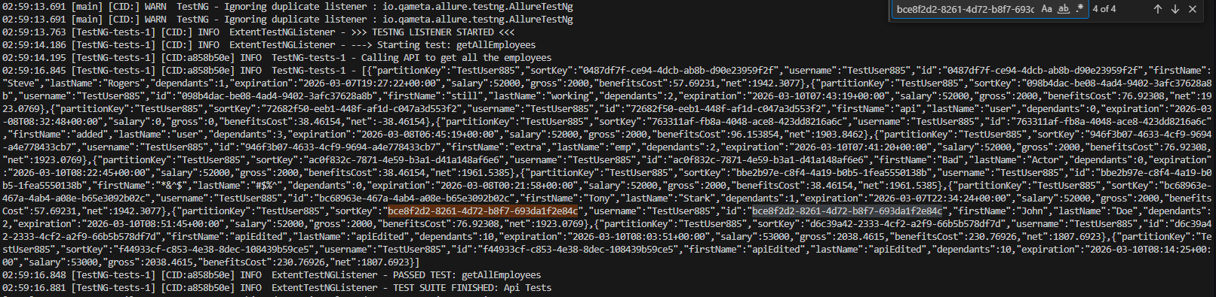

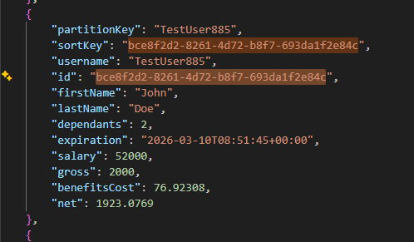

2 | When executing the API call | Employee should be updated with the specified username  Actual Result: username is not updated after calling the api with the new username

Result:
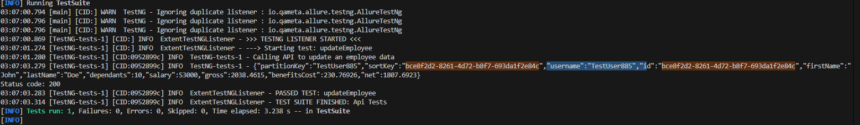

Bug title: Dependants goes to 0 after changing the fistname and lastname of an specified Employee
Tester’s Name & ID: Antonio Acosta Flores (antonio.acostafl@gmail.com)
Test Environment: https://wmxrwq14uc.execute-api.us-east-1.amazonaws.com
Priority: 3
Severity: 3

Steps to reproduce the bug:

No. Step | Step Description | Expected Result
1 | When only specifying the new firstname and lastname in the POST endpoint of an existent employee | When only specifying the new firstname and lastname in the POST endpoint of an existent employee
2 | When executing the API call to update the firstname and lastname | Employee should be updated keeping their dependents number

Steps with evidence:

No. Step | Step Description | Expected Result
1 | When only specifying the new firstname and lastname in the POST endpoint of an existent employee | When only specifying the new firstname and lastname in the POST endpoint of an existent employee

Result:
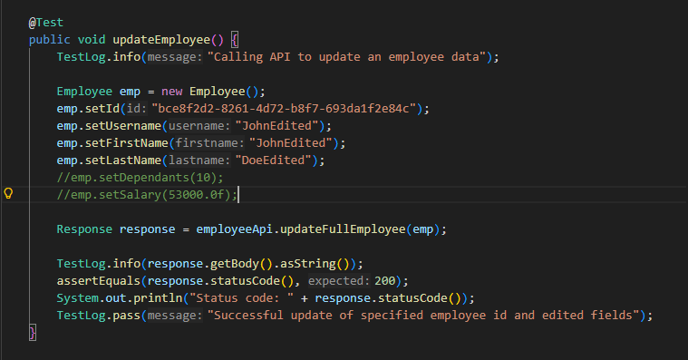

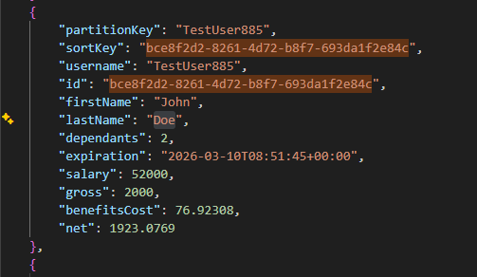

2 | When executing the API call to update the firstname and lastname | Employee should be updated keeping their dependents number  Actual Result: dependent goes to 0 after updating only the firstname and lastname

Result:
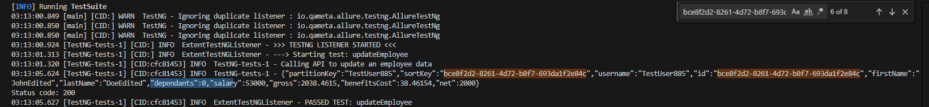

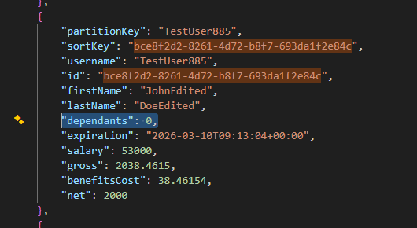

Bug title: Application throw error 500 when trying to look for specified Employee with an non-uuid
Tester’s Name & ID: Antonio Acosta Flores (antonio.acostafl@gmail.com)
Test Environment: https://wmxrwq14uc.execute-api.us-east-1.amazonaws.com
Priority: 3
Severity: 3

Steps to reproduce the bug:

No. Step | Step Description | Expected Result
1 | Having configured the API call to try to get the employee by Id with an invalid id | Having configured the API call to try to get the employee by Id with an invalid id
2 | When executing the API call to try to call an employee with an invalid id | API call should fail due invalid id.

Steps with evidence:

No. Step | Step Description | Expected Result
1 | Having configured the API call to try to get the employee by Id with an invalid id | Having configured the API call to try to get the employee by Id with an invalid id

Result:
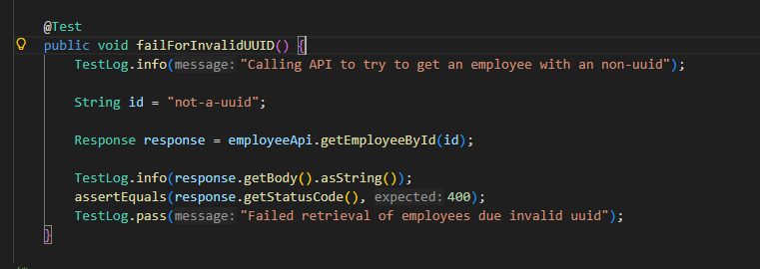

2 | When executing the API call to try to call an employee with an invalid id | API call should fail due invalid id.  Actual Result: api returns an 500 error.

Result:
